**PROBLEM SOLVING**

**(Solving various Problems using C Language)**

*Summer Internship Report Submitted in partial fulfillment*

*of the requirement for under graduate degree of*

**Bachelor of Technology**

In

**Computer Science Engineering**

By

**Vaishnavi Kulkarni**

**221710305024**

([https://github.com/Vaishnavikulkarni55](https://github.com/Vaishnavikulkarni55/Adv-Programming))

*Under the Guidance of*

Department Of Computer Science Engineering

GITAM School of Technology

GITAM (Deemed to be University)

Hyderabad-502329

                                                        July 2020

**DECLARATION**

I submit this industrial training work entitled **“SOLVING VARIOUS PROBLEMS WITH C LANGUAGE**” to GITAM (Deemed To Be University), Hyderabad in partial fulfillment of the requirements for the award of the degree of “**Bachelor of Technology**” in “**Computer Science Engineering**”. I declare that it was carried out independently by me under the guidance of  **Mr.** , Asst. Professor, GITAM (Deemed To Be University), Hyderabad, India.

The results embodied in this report have not been submitted to any other University or

Institute for the award of any degree or diploma.

Place: HYDERABAD    VAISHNAVI KULKARNI

Date:                                                                                                   221710305024

GITAM (DEEMED TO BE UNIVERSITY)

Hyderabad-502329, India.

Dated:

**CERTIFICATE**

       This is to certify that the Industrial Training Report entitled **“SOLVING VARIOUS PROBLEMS WITH C LANGUAGE”** is being submitted by VAISHNAVI KULKARNI(221710305024) in partial fulfillment of the requirement for the award of **Bachelor of Technology** **in Computer Science Engineering** at GITAM (Deemed To Be University), Hyderabad during the academic year 2019-20

                     It is faithful record work carried out by her at the **Computer Science Department**, GITAM University Hyderabad Campus under my guidance and supervision.

**Mr.                             Dr.S.Phani Kumar**

Assistant Professor                                                                   Professor  and HOD

Department of CSE                                                                 Department of CSE

**ACKNOWLEDGEMENT**

Apart from my effort, the success of this internship largely depends on the encouragement and guidance of many others. I take this opportunity to express my gratitude to the people who have helped me in the successful competition of this internship.

I would like to thank respected **Dr. N. Siva Prasad,** Pro Vice Chancellor, GITAM Hyderabad and **Dr. CH. Sanjay,** Principal, GITAM Hyderabad

I would like to thank respected **Dr.Phani Kumar,** Head of the Department of Computer Science Engineering for giving me such a wonderful opportunity to expand my knowledge for my own branch and giving me guidelines to present a internship report. It helped me a lot to realize of what we study for.

I would like to thank the respected faculties **Mr.** who helped me to make this internship a successful accomplishment.

I would also like to thank my friends who helped me to make my work more organized and well-stacked till the end.

                                                                                           VAISHNAVI KULKARNI

221710305024

**TABLE OF CONTENTS :**

**CHAPTER 1: INTRODUCTION**  1

**CHAPTER 2: ONLINE SHOPPING**

2.1 Problem Statement and Concepts used 2

2.2 Coding 6

2.3 Output 10

**CHAPTER 3: MORSE CODE**

3.1 Problem Statement and Concepts used 12

3.2 Coding 13

3.3 Output 14

**CHAPTER 4: CALCULATE DAY FROM GIVEN DAY**

4.1 Problem Statement and Concepts used 15

4.2 Coding 17

4.3 Output 18

**CHAPTER 5: GUESS THE TOSS OF A COIN**

5.1 Problem Statement and Concepts used 19

5.2 Coding 20

5.3 Output 21

**CHAPTER 6: ATM MACHINE**

6.1 Problem Statement and Concepts used 22

6.2 Coding 24

6.3 Output 26

**CHAPTER 7: SOFTWARE REQUIREMENTS**

7.1 Hardware Requirements 27

7.2 Software Requirements 27

**REFERENCES**  28

**1.INTRODUCTION**

Problem Solving is the Process of Designing and carrying out certain steps to reach a Solution. Five problems which are listed below are of different complexity and require different approach and logics in order to achieve desired Output/ Solution

1.**Online Shopping** **:** In this Problem we tend to see the process of online shopping and also the total cost in the cart after adding and deleting the items required by Customer.

2.**Morse Code** **:** In this Problem we can convert an English typed content into Morse Code.

3.**Calculate Day from Given Date** **:** In this Problem we can derive the day based on the date and year entered by the user.

4.**Guess the Toss of a Coin** **:** In this Problem we guess the output as head and tail and it displays as Correct or Not.

5.**ATM Machine** **:** In this problem we check multiple transactions based on the given conditions.

I have executed project in C language. I have used DEV C++ to execute the codes.

1

**2.PROBLEM 1 : ONLINE SHOPPING**

This project aims to develop an Online Shopping for Customers with the goal so that it is easy to shop your loved things. With the help of this you can carry out online shopping at your home.

**2.1 CONCEPTS USED :**

**1.** **Switch Statement** **:**  A SwitchStatement allows a variable to be tested for equality against a list of values. Each value is called a case, and the variable being switched on is checked for each switch case.

**Syntax :** switch(){

Case 1 :

break;

Case n :

break;

default :

break;

}

**2. Do-While loop :**  A do while loop is similar to while loop with one exception that it executes the statements inside the body of do-while before checking the condition.

**Syntax :** do{

Statements;

}while(condition);

**3. For loop :** A For loop is a control flow statement for specifying iteration,which allows code to be executed repeatedly.

**Syntax :** for(initialization,condition,increment)

{

Statements;

}

2

**4. Const Keyword** **:** Variables can be declared as constants by using the const keyword before the datatype of the variable. The constant variables can be initialized once only. The default value of constant variables are zero.

**Syntax :** const int a;

**5. If-else condition** **:** The if-else statement in C is used to perform the operations based on some specific condition. The operations specified in if block are executed if and only if the given condition is true.

**Syntax :** if {

Statements;

}

else{

Statements;

}

**6. Static Keyword :** Static keyword is mainly used for memory management. It can be used with variables, methods, blocks and nested classes.

**Syntax :** static int a;

**7. Break Statement** : The break is a keyword in C which is used to bring the program control out of the loop. The break statement is used inside loops or switch statement. The break statement breaks the loop one by one.

**Syntax :** break;

3

**EXPECTED OUTPUT :**

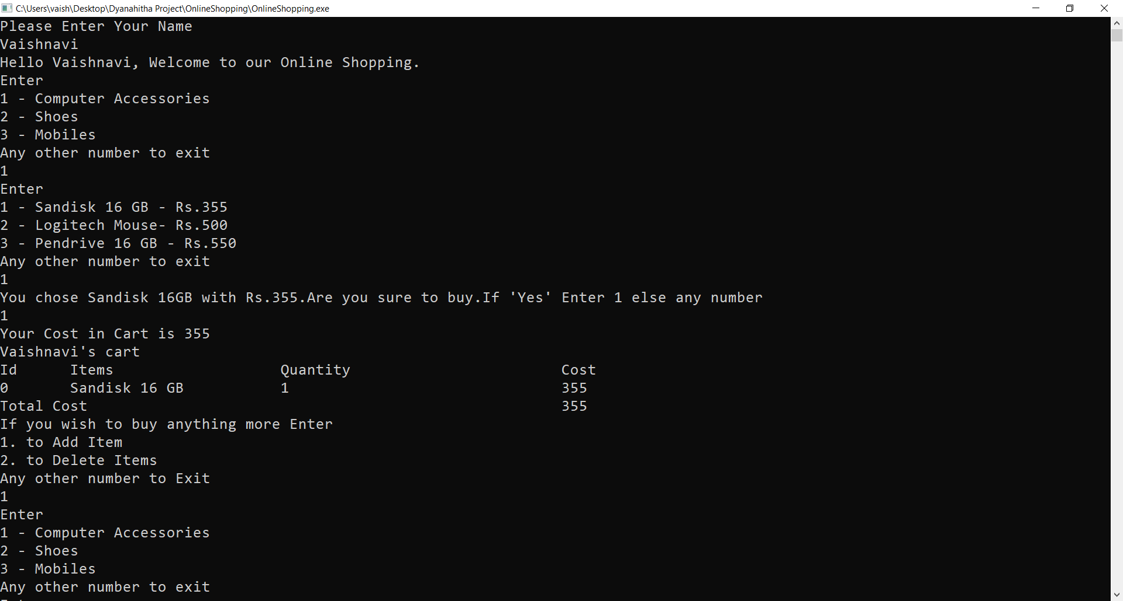

**Fig 2.1.1**

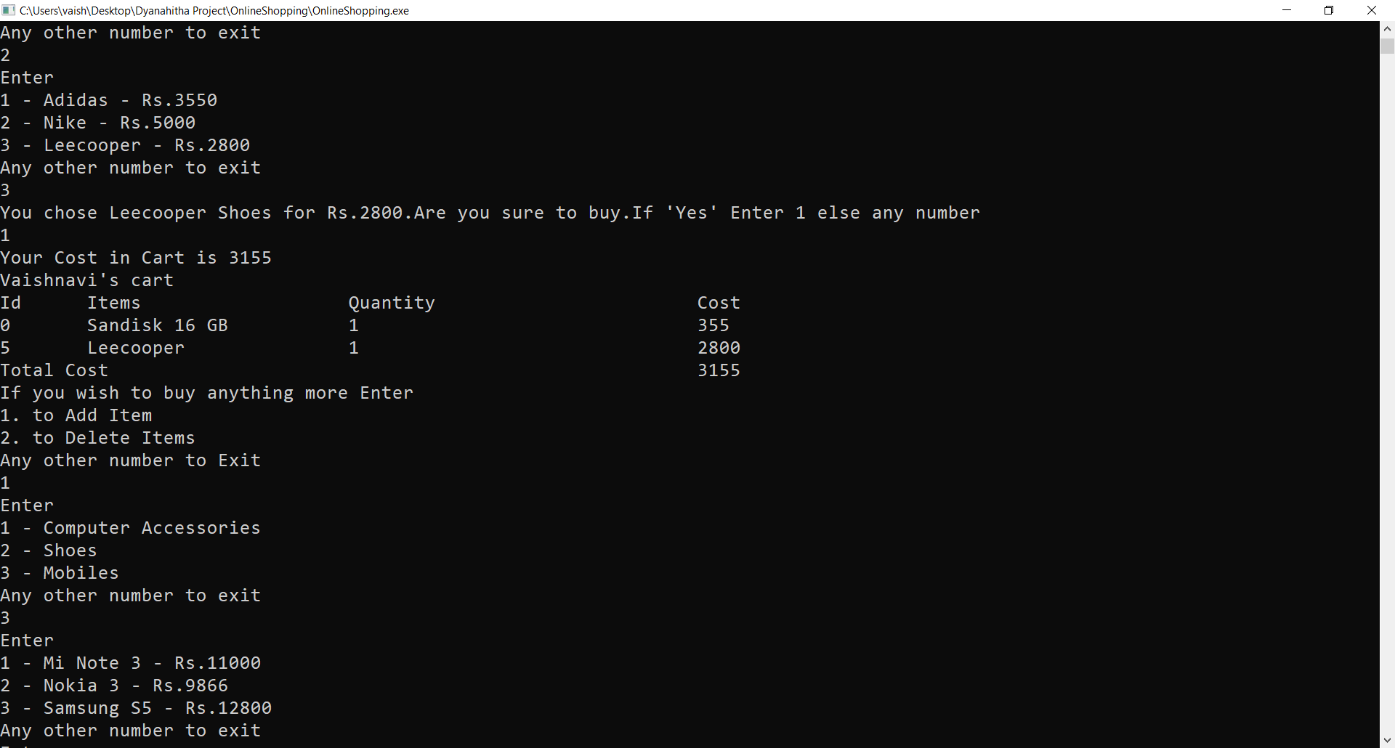

**Fig 2.1.2**

4

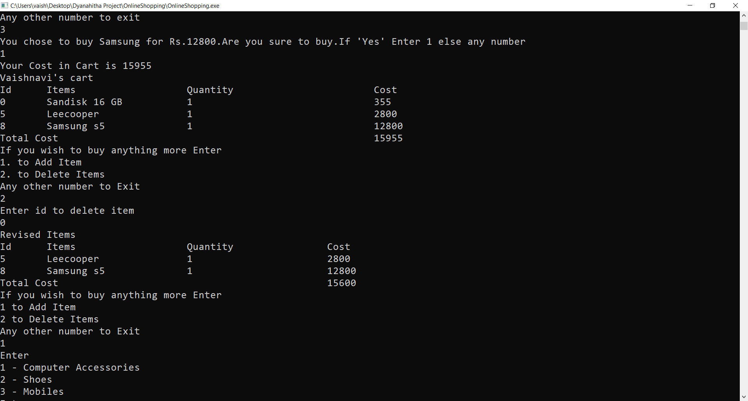

**Fig 2.1.3**

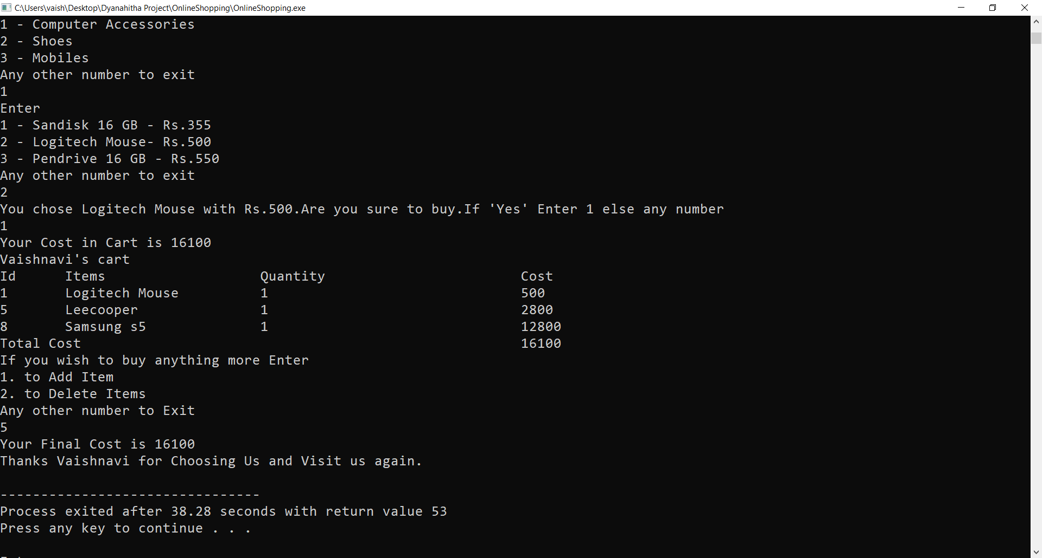

**Fig 2.1.4**

5

**2.2 CODING :**

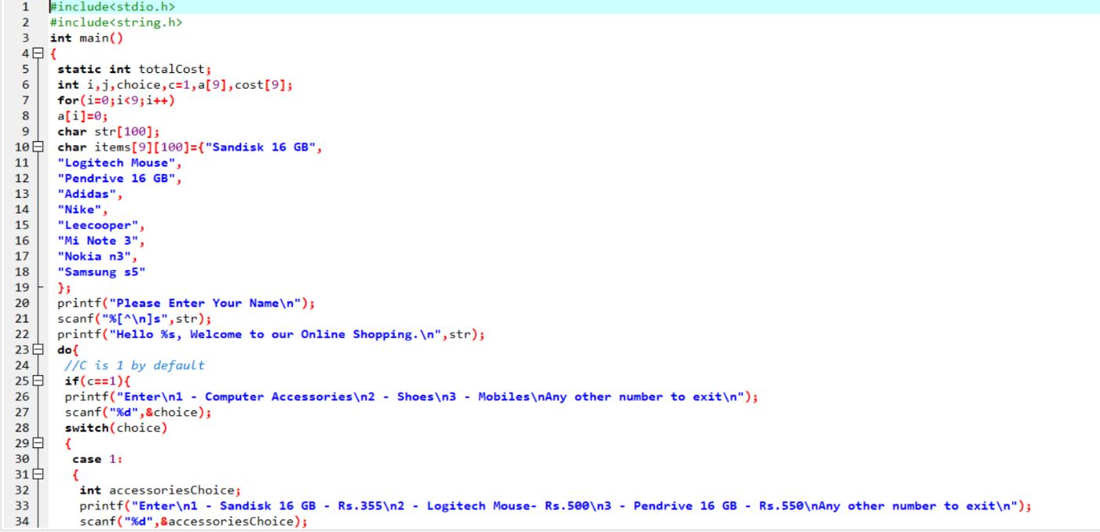

**Fig 2.2.1**

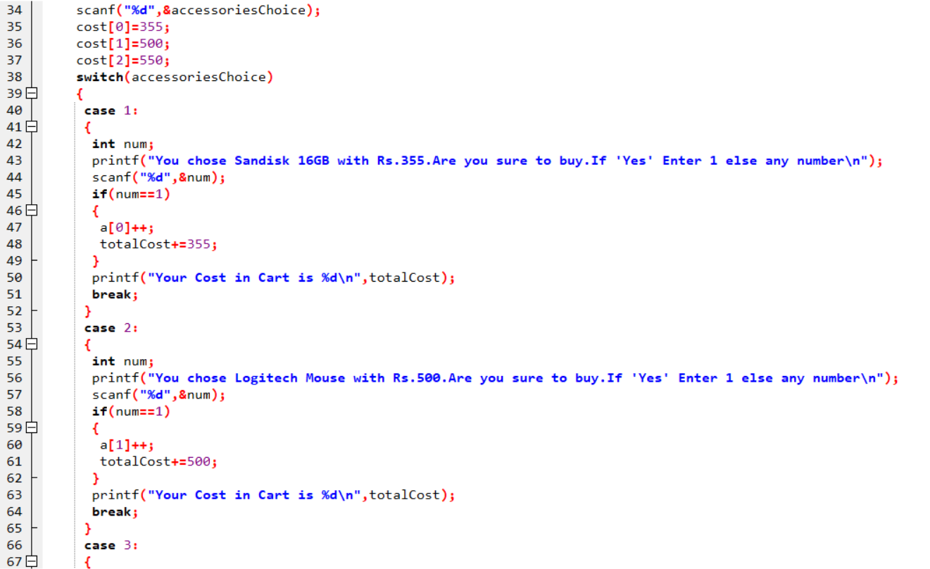

**Fig 2.2.2**

6

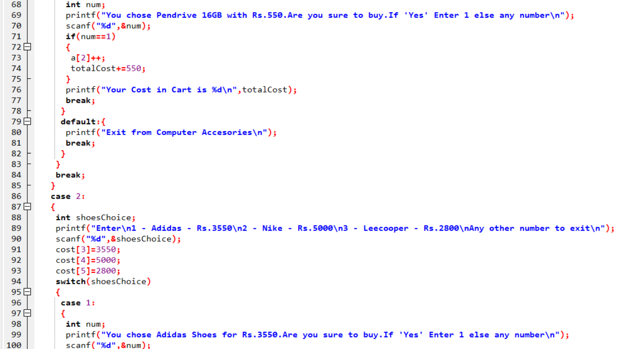

**Fig 2.2.3**

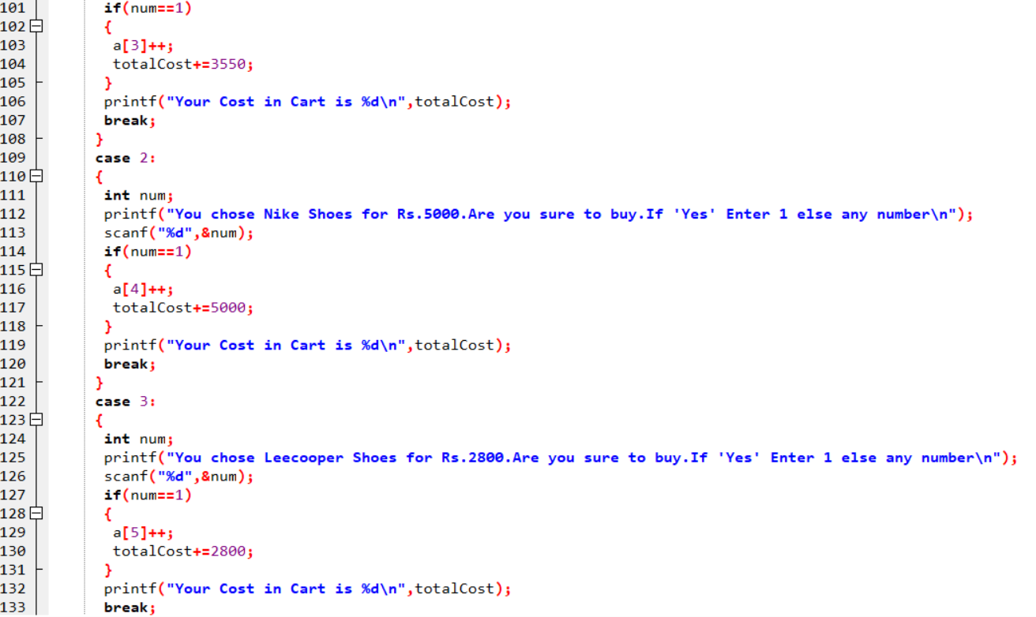

**Fig 2.2.4**

7

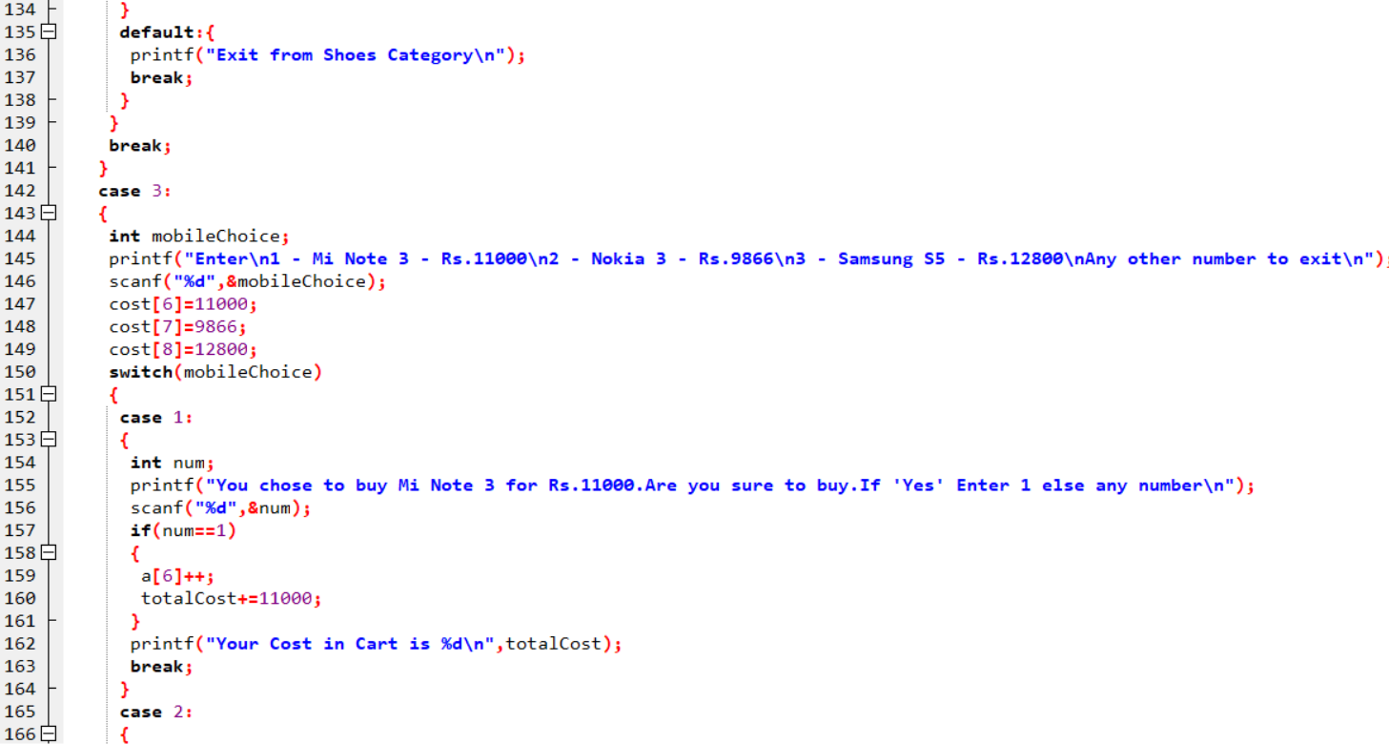

**Fig 2.2.5**

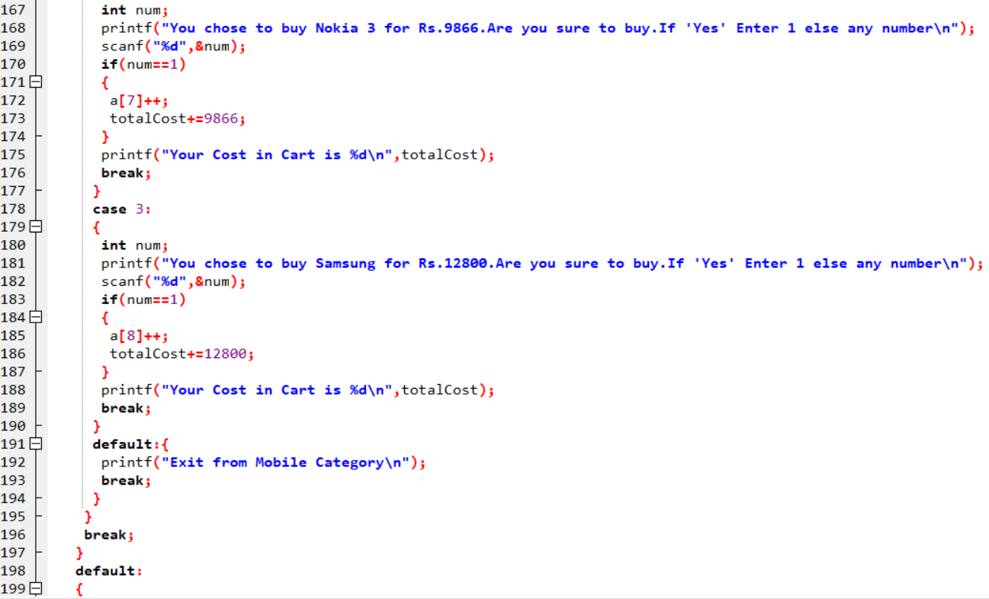

**Fig 2.2.6**

8

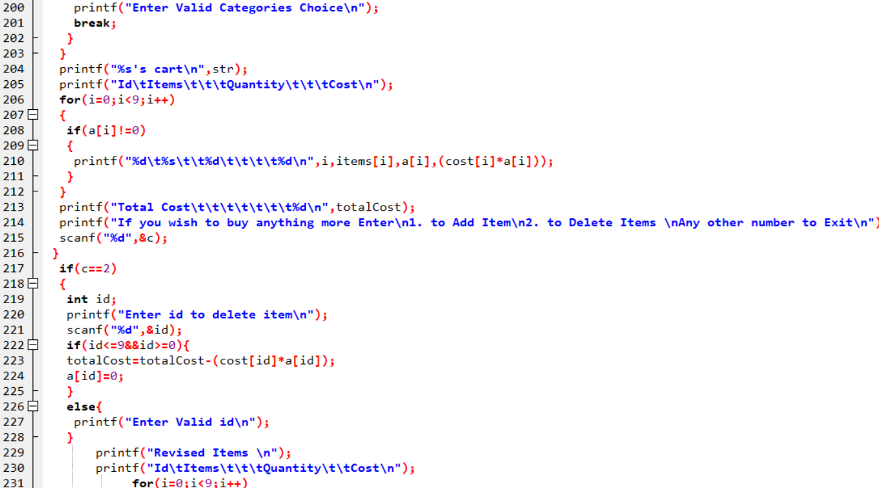

**Fig 2.2.7**

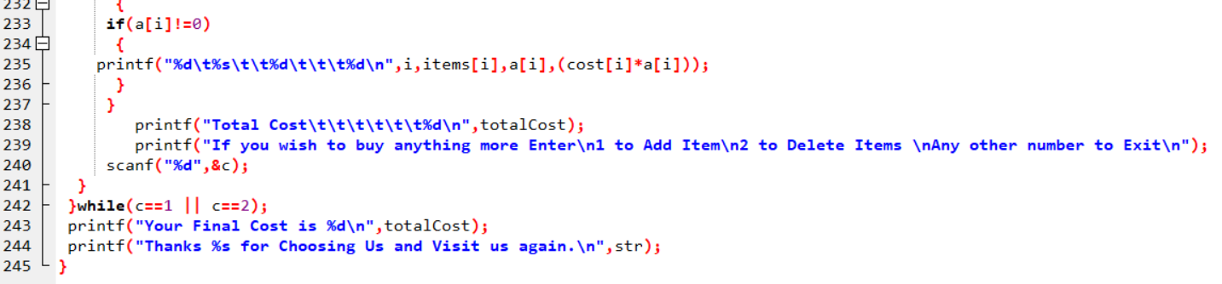

**Fig 2.2.8**

9

**2.3 OUTPUT :**



**Fig 2.3.1**



**Fig 2.3.2**

10



**Fig 2.3.3**



**Fig 2.3.4**

11

**3.PROBLEM 2 : MORSE CODE**

This Project aims to convert the given data into Morse Code.

**3.1 CONCEPTS USED :**

1. **While loop** **:** A while loop is a control flow statement that allows code to be executed repeatedly based on a given Boolean condition. The while loop can be thought of as a repeating if statement.

**Syntax :** while{

Statements;

}

2. **gets()** **:** The C library function char gets() reads a line from stdin and stores it.

**Syntax :** gets(name);

3**. Logical Operator AND (&&)** **:** The logical AND operator (&&) returns the boolean value TRUE if both operands are TRUE and returns FALSE otherwise. ... The first operand is completely evaluated and all side effects are completed before continuing evaluation of the logical AND expression.

**Syntax :** if (a&&b){

Printf(“Logical And”);

}

4. **If Statement** **:** The if-else statement in C is used to perform the operations based on some specific condition. The operations specified in if block are executed if and only if the given condition is true.

**Syntax :** if {

Statements;

}

else{

Statements;

}

12

**EXPECTED OUTPUT :**

**Fig 3.1.1**

**3.2 CODING :**

**Fig 3.2.1**

13

**3.3 OUTPUT :**

**Fig 3.3.1**

14

**4.PROBLEM 3 : CALCULATE DAY FROM GIVEN DAY**

This Project aims to calculate Day from given Date.

**4.1 CONCEPTS USED :**

**1. Pointers** **:** A pointer is a variable that stores the address of another variable. Unlike other variables that hold values of a certain type, pointer holds the address of a variable.

**Syntax :** int *ptr;

**2. Logical Operator OR ( | | )** **:** The logical-OR operator performs an inclusive-OR operation on its operands. The result is 0 if both operands have 0 values. If either operand has a nonzero value, the result is 1. If the first operand of a logical-OR operation has a nonzero value, the second operand is not evaluated.

**Syntax :** if(a | | b){

Statements;

}

**3. For loop** **:** A For loop is a control flow statement for specifying iteration,which allows code to be executed repeatedly.

**Syntax :** for(initialization,condition,increment)

{

Statements;

}

**4. Break statement** **:** The break is a keyword in C which is used to bring the program control out of the loop. The break statement is used inside loops or switch statement. The break statement breaks the loop one by one.

**Syntax :** break;

**5. Strcmp (String Comparison)** **:** The strcmp() function is used to compare two strings two strings str1 and str2 . If two strings are same then strcmp() returns 0 , otherwise, it returns a non-zero value. This function compares strings character by character using ASCII value of the characters.

**Syntax :** strcmp(str1,str2);

15

**6. If – else Statement** **:** The if-else statement in C is used to perform the operations based on some specific condition. The operations specified in if block are executed if and only if the given condition is true.

**Syntax :** if {

Statements;

}

else{

Statements;

}

**7. Arrays** **:** An array is a variable that can store multiple values. For example, if you want to store 100 integers, you can create an array for it.

**Syntax :** int array[100];

**EXPECTED OUTPUT :**

**Fig 4.1.1**

16

**4.2 CODING :**

**Fig 4.2.1**

**Fig 4.2.2**

17

**4.3 OUTPUT :**

**Fig 4.3.1**

18

**5. PROBLEM 4 : GUESS THE TOSS OF A COIN**

This Program is based on Heads or Tails that lets the user guess whether the flip of a coin results in heads or tails. The Program randomly generates an integer 0 or 1 which represents head or tail. The Program prompts the user to guess and reports whether the guess is correct or incorrect.

**5.1 CONCEPTS USED :**

**1. srand() :** The srand() function sets the starting point for producing a series of pseudo-random integers. If srand() is not called, the rand() seed is set as if srand(1) were called at program start. Any other value for seed sets the generator to a different starting point.

**Syntax :** void srand(unsigned rand)

**2. rand()** **:** rand() function is used in C to generate random numbers. If we generate a sequence of random number with rand() function, it will create the same sequence again and again every time program runs. Say if we are generating 5 random numbers in C with the help of rand() in a loop, then every time we compile and run the program our output must be the same sequence of numbers.

**Syntax :** int rand(void)

**3. If – else statement** **:** The if-else statement in C is used to perform the operations based on some specific condition. The operations specified in if block are executed if and only if the given condition is true.

**Syntax :** if {

Statements;

}

else{

Statements;

}

19

**EXPECTED OUTPUT :**

**Fig 5.1.1**

**5.2 CODING :**

**Fig 5.2.1**

20

**Fig 5.2.2**

**5.3 OUTPUT :**

**Fig 5.3.1**

21

**6. PROBLEM 5 : ATM MACHINE**

This problem enables the customer to Deposit amount to the bank account. Also the customer can withdraw amount and also can check balance in the Account.

**6.1 CONCEPTS USED :**

**1. while loop :** A while loop is a control flow statement that allows code to be executed repeatedly based on a given Boolean condition. The while loop can be thought of as a repeating if statement.

**Syntax :** while{

Statements;

}

**2. Do- while loop** **:** A do while loop is similar to while loop with one exception that it executes the statements inside the body of do-while before checking the condition.

**Syntax :** do{

Statements;

}while(condition);

**3. Switch Statement** **:** A SwitchStatement allows a variable to be tested for equality against a list of values. Each value is called a case, and the variable being switched on is checked for each switch case.

**Syntax :** switch(){

Case 1 :

break;

Case n :

break;

default :

break; }

**4. Break statement :** The break is a keyword in C which is used to bring the program control out of the loop. The break statement is used inside loops or switch statement. The break statement breaks the loop one by one.

**Syntax :** break;

22

**5. If statement** **:** The if-else statement in C is used to perform the operations based on some specific condition. The operations specified in if block are executed if and only if the given condition is true.

**Syntax :** if {

Statements;

}

else{

Statements;

}

**6. Logical Operator OR ( | | )** **:** The logical-OR operator performs an inclusive-OR operation on its operands. The result is 0 if both operands have 0 values. If either operand has a nonzero value, the result is 1. If the first operand of a logical-OR operation has a nonzero value, the second operand is not evaluated.

**Syntax :** if(a | | b){

Statements;

}

**EXPECTED OUTPUT :**

**Fig 6.1.1**

23

**Fig 6.1.2**

**6.2 CODING :**

**Fig 6.2.1**

24

**Fig 6.2.2**

**Fig 6.2.3**

25

**6.3 OUTPUT :**

**Fig 6.3.1**

**Fig 6.3.2**

26

**7. SOFTWARE REQUIREMENTS**

**7.1 Hardware Requirements :** This Project can be executed in any system or an android phone without prior to any platform. We can use any Online Compiler and Interpreter.

**7.2 Software Requirements :**

There are two ways to execute these projects

1. Online Compiler
2. Software for execution (Dev C++,CodeBlocks..)

Online compilers require only Internet Connection. We have many free Compilers with which we can code.

Software for execution need to be installed based on the user’s system specification. These help us to completely execute the project. These softwares are based on the platforms.

27

**REFERENCES**

1. <http://www.cprograms4future.com/p/online-shopping.html>
2. <http://www.cprograms4future.com/p/generate-morse-code.html>
3. <http://www.cprograms4future.com/p/guess-day-from-date.html>
4. <http://www.cprograms4future.com/p/toss-of-coin.html>
5. <http://www.cprograms4future.com/p/atm-machine.html>

28